

CSU SACRAMENTO DEPARTMENT OF ENGINEERING

Class: EEE 117L-06



Author: Professor

Miguel Tirado S. Aguilar

Partners:

Gabriela Munoz, Xiomara Validivia

September 12,2018

Time: 12:00 – 2:40pm

# **1 Introduction**

In this lab many tools and formulas were used to find the measurements of resistance, voltage, and current. Tools such as the power supply, oscilloscope, and digital multimeter. The digital multimeter was one of the most important tools because it allowed my group mates and I to accurately measure the circuit elements. The power supply is self-explanatory as it just provides us the voltage and current into our circuit. The oscilloscope allowed us to see the dc voltage onto a screen and acted as its own separate resistor connected to our circuit. The oscilloscope has a resistance that can change with the switch from x1 to x10 probe setting. This fact was crucial when making our measurements and calculations. Formulas used in this lab were voltage divider, Current Divider, Kirchhoff’s Voltage law, Kirchhoff’s current law and Ohms law. Voltage division was used to find the Actual voltage. Finally in this lab the team will measure the resistance, voltage, and current on three different circuits with different requirements for certain circuit elements such as voltage (Loaded voltage, Unloaded voltage, x1,x10) .

# **2 Purpose**

The Purpose of this lab is to gain experience with taking circuit element measurements also to get familiar with the tools available for us and finally to use are eng 17 formulas to find are actual measurements for our circuit elements. In the first part of this lab we were tasked to acquire all the measured resistance from a total of 5 resistors and the oscilloscope. After that, are next step was to properly create the circuit shown down in Fig 1 Voltage divider on our breadboard.

A screenshot of a cell phone

Description generated with very high confidence

Now for part 2 A. we are tasked to measure the voltage from resistor 1, resistor 2, and the source on our circuit. Also, by using KVL and voltage division we are able to verify the resistor voltages by comparing them to are measured voltages. Part 2 B. we need to connect a x1 probe in parallel to Resistor 2 on Fig 2 Probe Connection. Then we measure the loaded voltages with a x1 probe setting. For Part 2 C we only change the probe setting from x1 to x10 therefore increasing the probes resistance. It was crucial for my team and I to use voltage division to find are actual loaded voltage values.

A screenshot of a cell phone

Description generated with very high confidence

Now for part 3 we had to create the circuit shown in Fig 3 with the other three resistors. Then we are tasked to measure the current through all three resistors. It was crucial for my teammates and I to connect the Ammeter in series within each circuit element we wanted to measure. Also, when calculating for each current we had to use the current division formula to find the current through resistor R4 and R5. Note that for R equivalent, its asking for the equivalent resistance between R4 and R5 not the whole circuit.

A screenshot of a cell phone

Description generated with very high confidence

# 3 Analysis and Discussion

# The following table shows the Resistance measurements for all resistors used and the resistance from the oscilloscope. It shows the specified value, measured value, and the percent error. The percent error shows us how off are measured values are from the specified values. Note that we measure the resistance of the oscilloscope while on and while off because there is a slight difference between them. Since the oscilloscope has two setting for the probes such as x1 and x10 there will be two measurements for each setting as well.

|  |  |  |  |
| --- | --- | --- | --- |
| **Table 1: Resistance Measurements** | | | |
| **Part I Resistance Measurements** |  |  |  |
| Resistor | Specified Value | Measured Value (Ω) | % Error |
| R1 | 100kΩ | 98.61k | 1.39 |
| R2 | 300kΩ | 298k | 0.67 |
| R3 | 2kΩ | 1.99k | 0.5 |
| R4 | 1kΩ | 0.99k | 0.5 |
| R5 | 3kΩ | 2.98k | 0.67 |
| Rx1on | 1M | 1.99M | 0.5 |
| Rx1off | 1M | .99M | 0.5 |
| Rx10on | 10M | 9.99M | 0.5 |
| Rx10off | 10M | 10.18M | 1.8 |

Voltage division was used on figures 1 and 2 to verify the measured voltages with our multimeter. A 100 KΩ and a 300 KΩ resistor were used for R1 and R2 and were powered by a 2V source. The calculation for part 2A is as follows.

$V1=\frac{Rk}{Req}Vs=\frac{100KΩ}{100KΩ+300KΩ}*2v= 0.5$ v

$V2=\frac{Rk}{Req}Vs=\frac{300KΩ}{100KΩ+300KΩ}*2v= 1.5$ v

|  |  |  |  |
| --- | --- | --- | --- |
| **Table 2 Voltage Divider** | | | |
| **Part II Voltage Measurements** |  |  |  |
| A. Unloaded Readings |  |  |  |
| Circuit Element | Specified Value (V) | Measured Value (V) | % Error |
| Vs1 | 2 | 1.99 | 0.50 |
| R1 | 0.5 | 0.49 | 2.04 |
| R2 | 1.5 | 1.49 | 0.50 |

# Voltage division was used on Figure 2 however a probe was added to the circuit and acted as a third resistor. Therefore, the voltage readings on this circuit were now considered loaded with the introduction of the probe. The probes resistance was 1000 KΩ or 1 MΩ which was in parallel with R2 in the circuit. Therefore this required us to add R2 and x1 probe resistance in parallel thus allowing us to find the voltage between R1 ,R2, and the probe by using voltage division.

The calculation for part 2 B is as follows:

$R2\backslash \backslash R3 =\frac{1000*300}{1000+300}KΩ=230.77KΩ$

$Vr1=\frac{Rk}{Req}Vs=\frac{100KΩ}{100KΩ+230.77KΩ}*2v= 0.60V$

$Vr(2,3)=\frac{Rk}{Req}Vs=\frac{230KΩ}{100KΩ+230.77KΩ}*2v= 1.39V$

Please Note that R3 is the Probe with a x1 setting on it, therefore R3 has a resistance of 1 megaohm or 1000 Kiloohms.

|  |  |  |  |
| --- | --- | --- | --- |
| **Table 3 Probe connection Fig 2 x1** | | | |
| B. Loaded Readings |  |  |  |
| Circuit Element | Specified Value (V) | Measured Value (V) | % Error |
| Vs1 | 2 | 1.99 | 0.50 |
| R1 | 0.6 | 0.59 | 1.69 |
| R2 | 1.39 | 1.38 | 0.72 |

In this part still using Fig 2 but now the probe is set to x10 instead of x1 meaning the resistance was increased to 10 megaohms. Note that since R2 and the Probe are in parallel the voltage is the same between them because that is a characteristic of resistors in parallel. Our data in this table seems to be accurate with minimal percent error. The calculations for part 2 C are as follows:

$R2\backslash \backslash R3 =\frac{10,000*300}{10,000+300}KΩ=291.26KΩ$

$Vr1=\frac{Rk}{Req}Vs=\frac{100KΩ}{100KΩ+291.26KΩ}*2v= 0.51V$

$Vr(2,3)=\frac{Rk}{Req}Vs=\frac{291.26KΩ}{100KΩ+291.26KΩ}*2v= 1.48V$

Please Note that R3 is the Probe with a x10 setting on it, therefore R3 has a resistance of 10 megaohm or 10,000 Kiloohms.

|  |  |  |  |
| --- | --- | --- | --- |
| **Table 4 Probe Connection x10** | | | |
| C. Loaded Voltage Readings (x10 Probe parallel to R2) |  |  |  |
| Circuit Element | Specified Value (V) | Measured Value (V) | % Error |
| Vs1 | 2 | 1.99 | 0.50 |
| R1 | 0.51 | 0.5 | 2.00 |
| R2 | 1.48 | 1.48 | 0.00 |

Finally, in the third part this table shows our current measurements for R3, R4, and R5. These measurements were by far the most accurate however the calculation for these were a bit more tedious and confusing as we had to use current division. As I previously have stated Req on the current division formula involves resistors R4 and R5 and not the entire circuit because only R4 and R5 are in parallel. This was a bit confusing at first when I was initially trying to calculate for my current because I wasn’t using the formula properly. Also note that the voltage in this circuit is now 12V and involves the circuit in Fig 3. The calculation for part 3 are as follows:

$R4\backslash \backslash R5 =\frac{1*3}{1+3}KΩ=0.75KΩ$

$I=\frac{v}{R}=\frac{12V}{2.75Ω}=4.36mA$

$I_{k}=\frac{R_{eq}}{R_{k}}i_{s}=\frac{750Ω}{1000Ω}\left(4.36mA\right)=3.27mA$

$I_{k}=\frac{R_{eq}}{R_{k}}i_{s}=\frac{750Ω}{3000Ω}\left(4.36mA\right)=1.09mA$

|  |  |  |  |
| --- | --- | --- | --- |
| **Table 5 Current Divider** | | | |
| **Part III Current Measurements** |  |  |  |
| Circuit Element | Specified Value (mA) | Measured Value (mA) | % Error |
| R3 | 4.36 | 4.36 | 0.00 |
| R4 | 3.27 | 3.27 | 0.00 |
| R5 | 1.09 | 1.09 | 0.00 |

# **4 Conclusion**

In this lab we have learned how to use tools such as the oscilloscope, digital multimeter and power supply as well as using methods such as voltage division, current division, Kirchhoff’s Voltage law, Kirchhoff’s Current Law, ohms law and resistors in parallel or series. The highest percent error was about 2.04 percent and the lowest was 0 percent. Our results were accurate with our calculations therefore solidifying our data and analysis. However, some sources of error could have been the resistors because they were not 100 percent accurate with there labeled resistance’s. Therefore, the methods such as current division and voltage division were crucial for verifying are measured values. Thus, concluding this lab on DC measurements.

# **5 Appendix**

KVL and KCL are used to prove voltage division and current division amongst resistors. These methods are used to solve for individual voltages and currents.

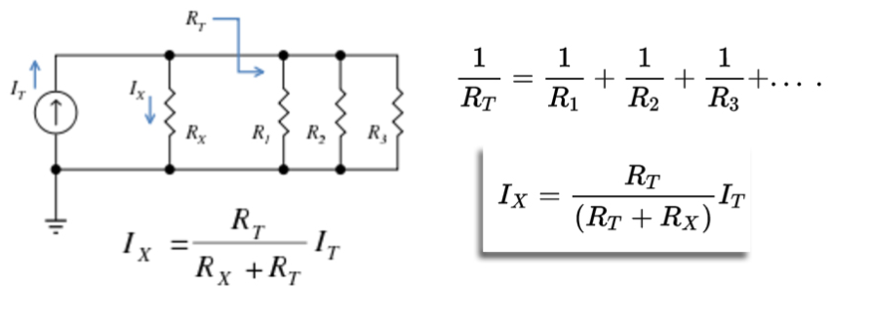

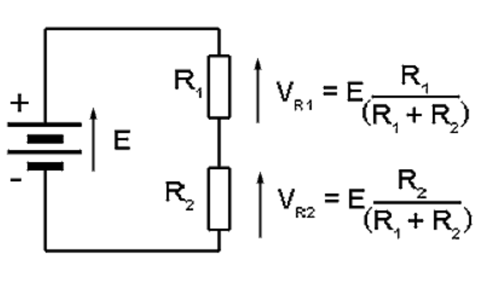

Kirchhoff’s Current law states that the sum of all the currents going into one node is the same as the sum of the currents going out the node. While Kirchhoff’s Voltage law states the sum of all the voltages in a loop are equal to zero. Ohms law states that voltage is equal to the current times the resistance.